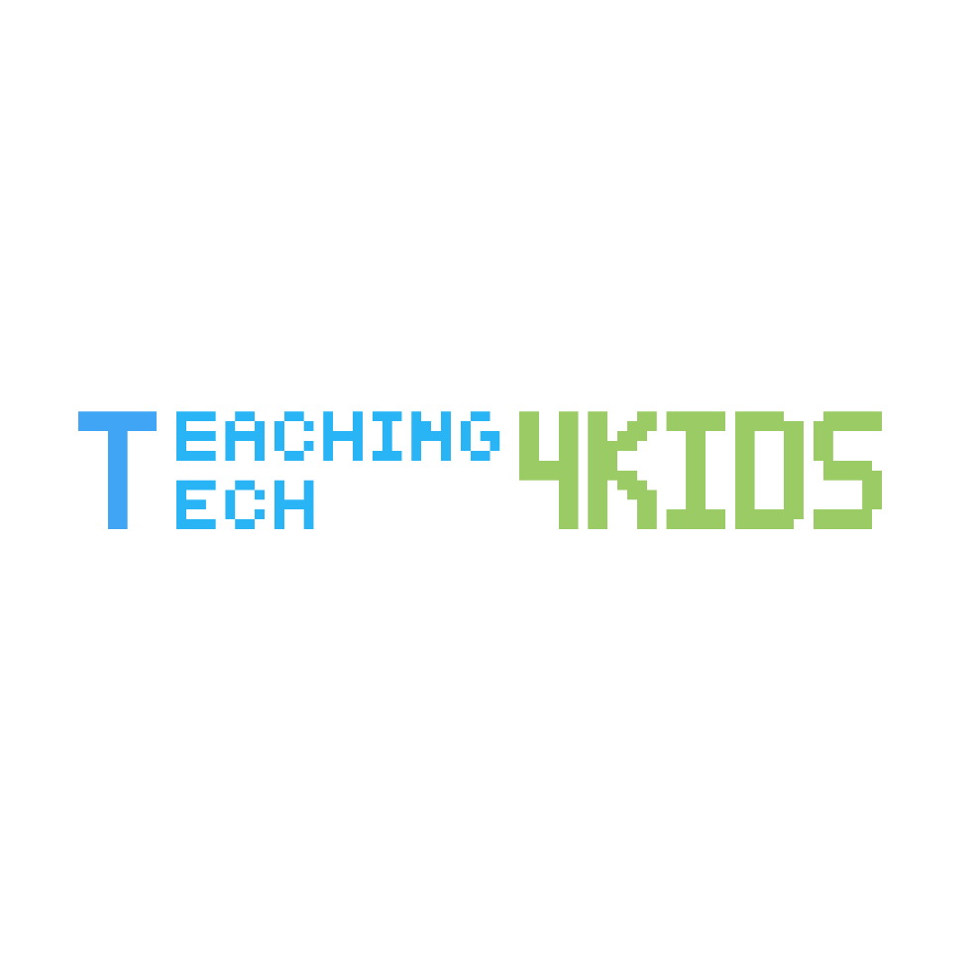

About us: We are TeachingTech4Kids, an educational non-profit organization that hosts live classes relating to technology. New fields in the 21st century are becoming more in demand in the job market because technology is growing rapidly. We want to teach young kids the essential skills needed to be successful in the future.
Mission: Our mission is to help as many elementary and middle school kids as possible. This means that our classes will be free of charge. We want all kids to have the same learning opportunity!
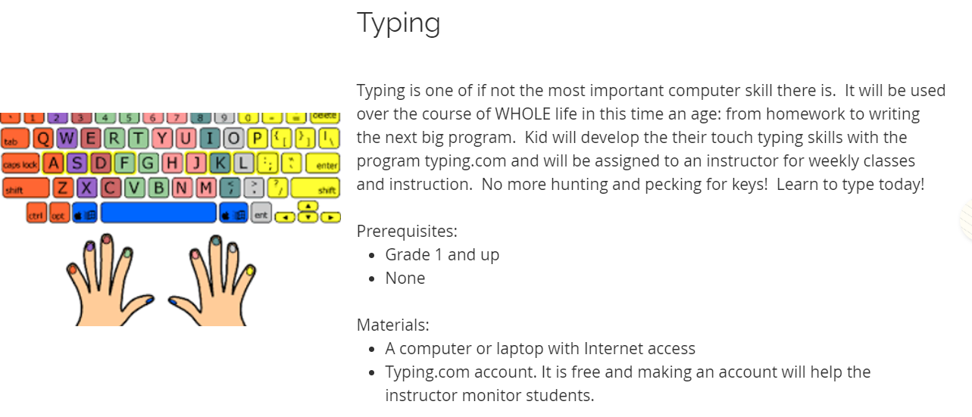
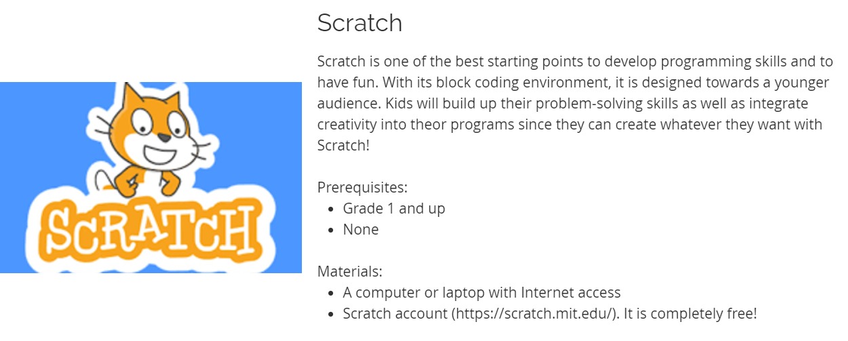
Our Prospective Classes:
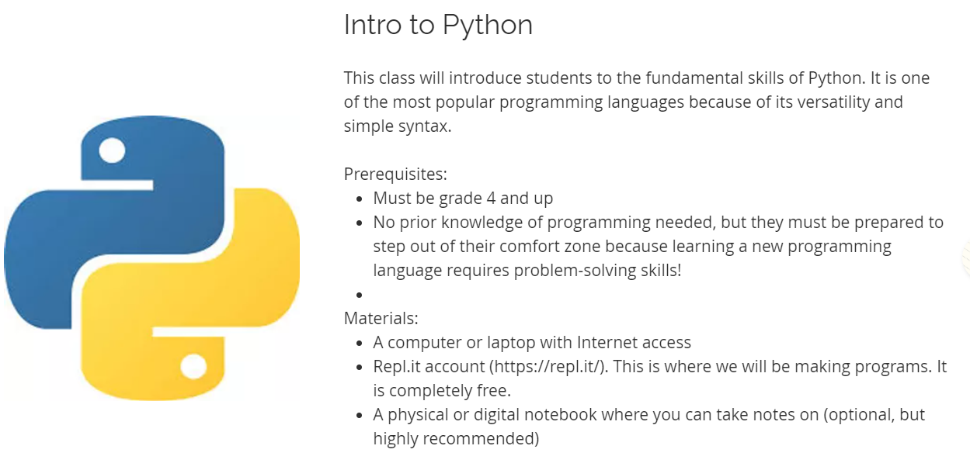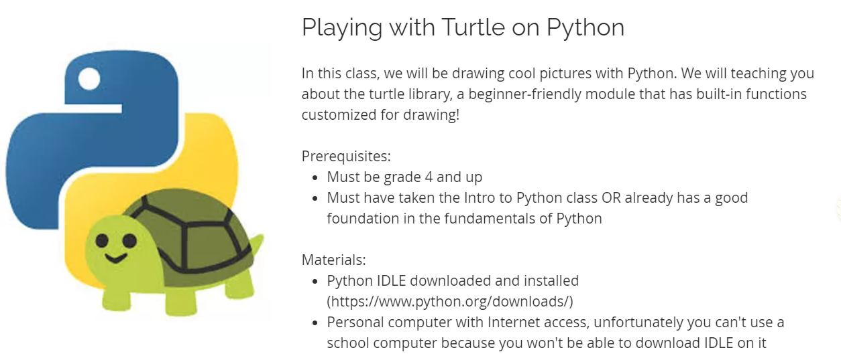

We are still developing our organization! More classes are going to come soon based on your recommendations!
Survey: Please fill out the survey below because it will help us come up with more classes and help our organization grow! https://forms.gle/hSGTXa1FmfmhnjmC8
Contact Info: If you have any questions, email us at teachingtech4kids@gmail.com!
Other Info: We currently have a website that will be open to everyone soon!

